SOC INCIDENT ANALYSIS REPORT
Wazuh SIEM-Based Threat Detection Lab

1. Executive Summary
This report presents a comprehensive investigation of security events observed within a simulated Security Operations Center (SOC) environment over a monitoring period of approximately 30 days, during which more than 75,000+ log events were collected and analyzed.
The environment was designed to replicate a real-world monitoring setup, consisting of a Wazuh SIEM platform, a Windows 11 endpoint configured with Sysmon for enhanced telemetry, and a Kali Linux system used to simulate adversarial techniques.
The primary objective of this investigation was to evaluate the effectiveness of SIEM-based detection across three core attack scenarios:
- Credential brute-force attempts
- Command execution via PowerShell
- Network reconnaissance activity
The findings indicate that authentication-based attacks were detected with strong visibility and correlation, while execution and reconnaissance activities demonstrated limited detection due to baseline configuration constraints.

2. Environment Architecture
The SOC lab environment was structured to simulate a layered detection pipeline similar to enterprise SOC deployments.
Components
- Wazuh SIEM Server (Amazon Linux 2023)
- Windows 11 Endpoint (Sysmon + Wazuh Agent)
- Kali Linux Attacker System

Operational Flow
Attacker → Endpoint Activity → Sysmon & Security Logs → Wazuh Agent → Wazuh Manager → Indexer → Dashboard → Analyst Investigation
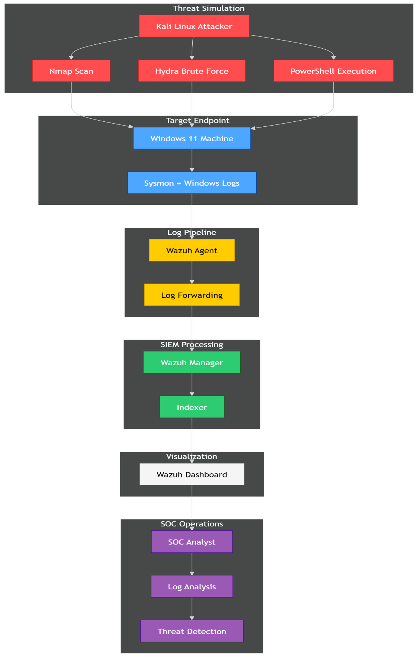

This architecture enables centralized log aggregation, real-time analysis, and visualization for security monitoring.

3. Scope of Analysis
- Observation Period: ~30 days
- Total Logs Analyzed: 75,000+
Data Sources
- Windows Security Logs
- Sysmon Event Logs
- Wazuh Alerts
Focus Areas
- Authentication anomalies
- Process execution behavior
- Network scanning patterns
- Temporal and behavioral correlation

4. Incident Timeline (Analytical Narrative)
Phase 1 – Baseline Behavior
System activity remained stable, with logs generated at consistent intervals. Authentication events and process execution patterns aligned with normal system usage.

Phase 2 – Attack Initiation
A sudden surge in authentication failures was observed, primarily associated with Event ID 4625 (failed logon events).
Key indicators:
- High concentration of login failures
- Repetitive targeting of accounts
- Activity originating from a single source

Phase 3 – Peak Attack Window
During this stage:
- Log volume increased sharply within a short duration
- Alert frequency significantly exceeded baseline levels
- Authentication attempts were continuous and automated
This phase clearly reflects an active brute-force attempt.

Phase 4 – Execution Activity
Limited process execution events were recorded, including PowerShell activity via Sysmon (Event ID 1).
Observations:
- Minimal alert generation
- Lack of deep inspection
This indicates logging presence but insufficient detection tuning.

Phase 5 – Reconnaissance Activity
Port scanning and discovery techniques were executed using Nmap.
Observations:
- No substantial alerts generated
- No visibility at SIEM level
This reflects absence of network-level detection capability.

Phase 6 – Post-Incident State
- No successful authentication detected
- No lateral movement observed
- System integrity remained intact

5. Log & Threat Analysis

5.1 Log Volume Analysis
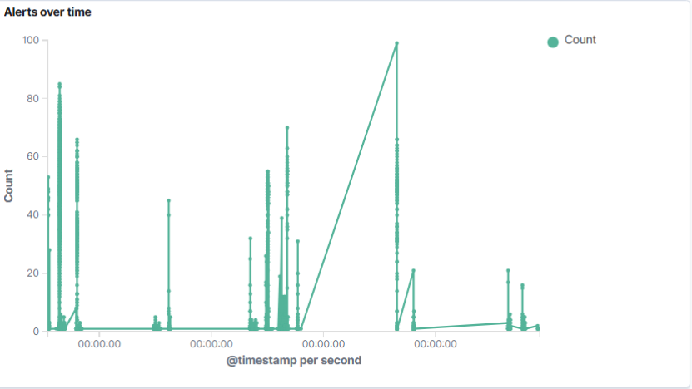
Throughout the monitoring period, logs were generated consistently under normal conditions. However, during the attack phase, a rapid and concentrated spike in log activity was observed.
Unlike typical fluctuations, this spike occurred within a narrow time window, indicating automated activity rather than organic system usage.
Analyst Insight:
Temporal spikes often serve as early indicators of anomalous behavior. In this case, the spike directly identified the attack window without requiring deep log inspection initially.

5.2 Authentication Analysis
Authentication logs revealed a dominant presence of failed login attempts (Event ID 4625).
Key characteristics:
- Extremely high frequency
- Uniform failure patterns
- Single-source origin
- No successful authentication
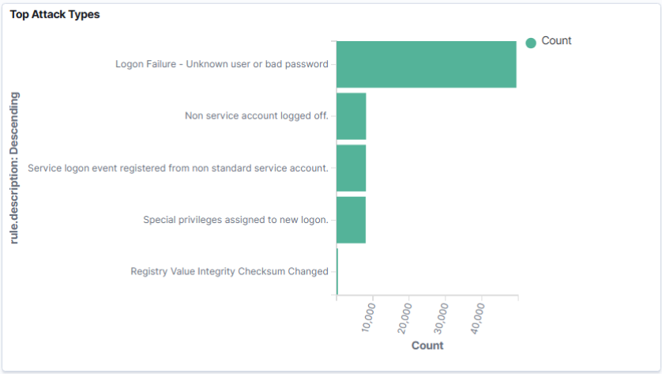
This behavior strongly indicates automated credential attacks rather than human interaction.
Analyst Insight:
Consistency and speed of attempts are key indicators differentiating automated attacks from legitimate user errors.

5.3 Process Execution Analysis
Process creation logs captured via Sysmon provided visibility into system-level activity.
Findings:
- PowerShell execution observed
- Low alert generation
- Lack of contextual detail
This suggests that while telemetry collection is functioning, detection logic is insufficient for identifying suspicious execution.
Analyst Insight:
Execution-based detection requires deeper inspection of command context rather than relying on process creation alone.

5.4 Network Activity Analysis
Reconnaissance activity was simulated using scanning tools.
Findings:
- No meaningful alerts generated
- Activity not visible at SIEM level
This limitation is attributed to lack of network monitoring capabilities within the environment.
Analyst Insight:
Host-based logging alone is insufficient for detecting network discovery techniques.

5.5 Raw Log Validation
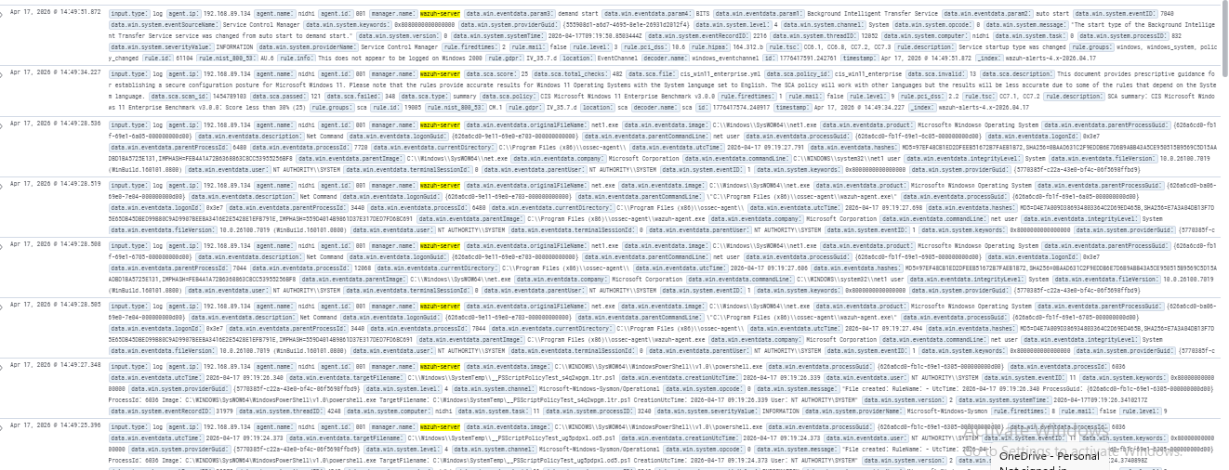
Manual inspection of raw logs confirmed:
- Repetitive authentication failures
- Closely spaced timestamps
- Consistent source IP
This validates that dashboard observations accurately reflect underlying log data.

5.6 Cross-Event Correlation
By correlating logs across different sources:
- Sudden increase in failed logins
- High-frequency repetition
- Single source origin
- No successful compromise
A complete attack pattern was reconstructed.
Analyst Insight:
Correlation transforms isolated events into actionable intelligence and is a core SOC capability.
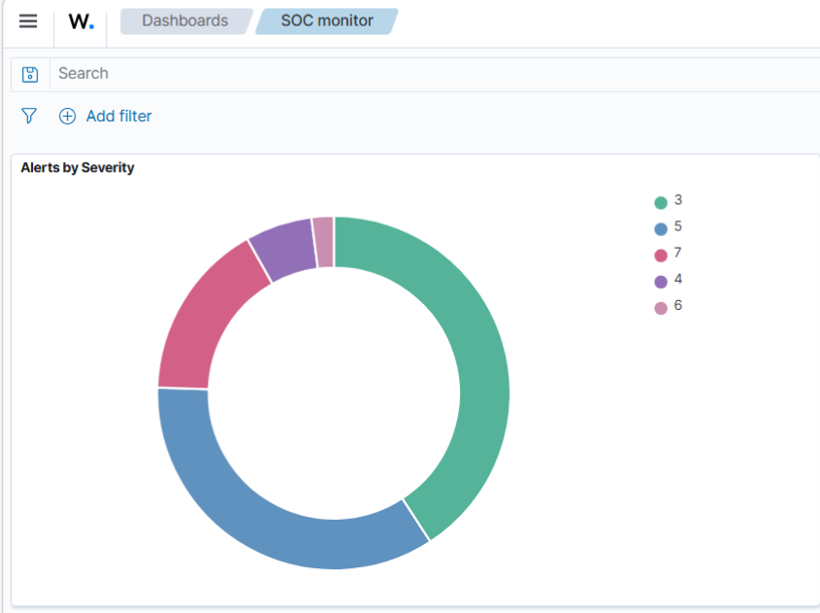

6. Event Correlation
Detailed correlation revealed:
- Time-clustered authentication failures
- Consistent behavioral patterns
- Absence of escalation activity
This confirms a structured brute-force attack sequence rather than random system noise.

7. Detection Capability Assessment
Detection Area | Effectiveness
Brute-force | Strong
PowerShell | Moderate
Reconnaissance | Weak

8. MITRE ATT&CK Mapping
Technique | ID | Evidence
Credential Brute Force | T1110 | Failed logins
Command Execution | T1059 | PowerShell logs
Network Discovery | T1046 | Scanning behavior

9. Detection Gaps & Limitations
- Limited detection of reconnaissance activity
- Insufficient execution-level monitoring
- Absence of network visibility
- Dependency on default SIEM rules

10. Incident Severity & Impact
- Severity Level: Medium–High
- Attack Type: Brute-force authentication
- Impact: Unauthorized access attempts
- Outcome: No compromise

11. Response & Mitigation
Recommended actions:
- Enforce account lockout policies
- Block malicious source IPs
- Strengthen authentication mechanisms
- Improve SIEM detection rules
- Integrate network monitoring tools

12. Analyst Observations
This investigation highlights that:
- High-volume attacks are easier to detect
- Advanced techniques require deeper visibility
- Detection effectiveness improves with tuning
- Correlation is critical for accurate analysis

13. Conclusion
The SOC simulation successfully demonstrates detection workflows in a realistic environment.
While brute-force activity was effectively identified, the limitations observed in execution and reconnaissance detection emphasize the need for continuous improvement in SIEM configuration and monitoring depth.

